

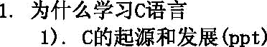

##### C ÃĄÖ

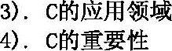



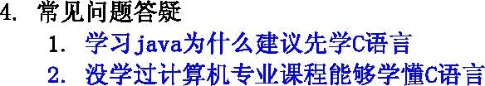









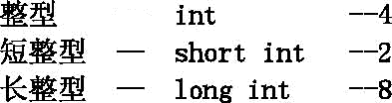

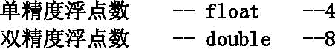

char









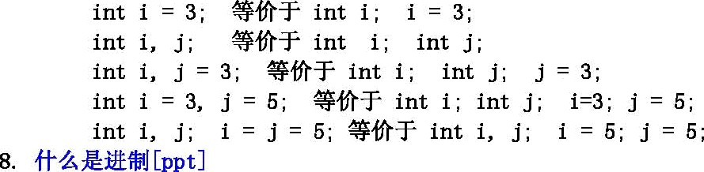

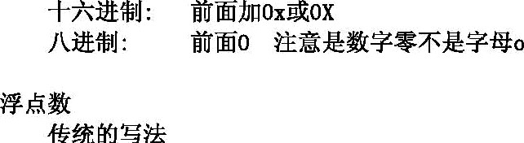

float z = 3. 2 ¡ //J

##### float x = B 2e]; //xÃ ]200

float x = 123. 45e—2 ¡ //x(ĆI{ll( 1. 2345

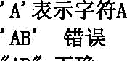



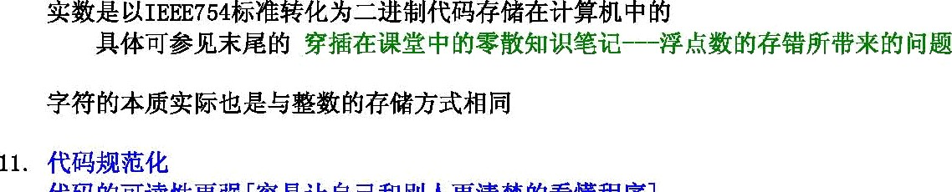



##### 1 Ą/ = 8Â

**1E 1024ĄĄ**

**1@ 1024Ł**

**1G 1024¥**



int i = 45 ¡

long j = 102345 ¡



f1oat z = 6. 6;

double y = 8. 8 ¡

**Drintf(’]f Elf\n, z y’);**

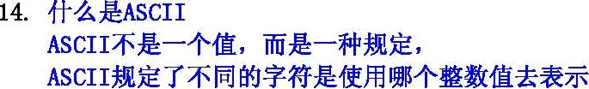

|  |  |  |
| --- | --- | --- |
| ’A’ |  | 65 |
| ’B’ |  | 66 |
| ’ a’ | —— | 97 |
| ’ b’ | —— | 98 |
| ’ 0’ | —— | 48 |



**Drintf()** -- **#AØĄ #Ø]1 m HY [Æë]**

* 1. **printf( ’Ą Ą’);**

**2. printf( ’4èŁÜĄ]]%’, MbBÆ);**

s » **ın‹f(’Æbø*1R1 Wbø*1R2.** . .’, **Æb** 1. Wb\*\*** 2, . . . .).

### 4 Drintf( 4ÑdØ#J W D#MØØ1Ą’, ĘT Æ);







! anu¡¡uos













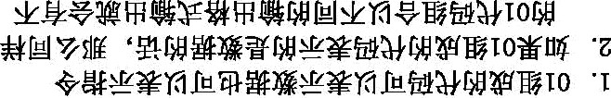



O#

a¡qnop



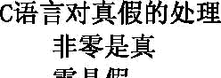



  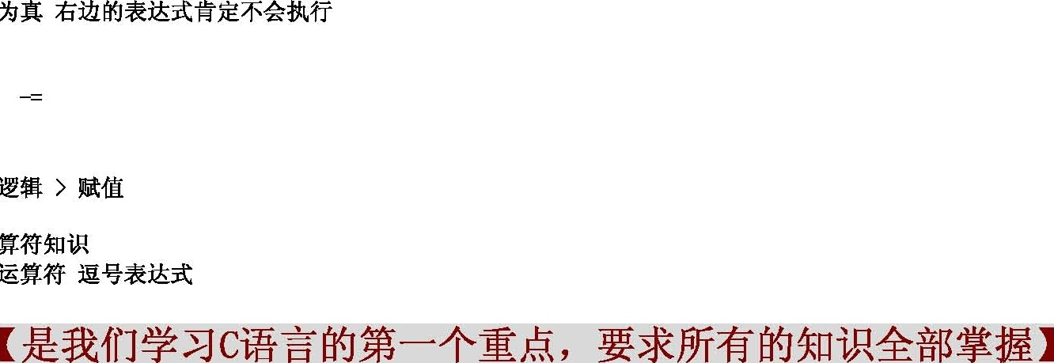



if



if (ÆMK)

**2. if#%i [»]#**

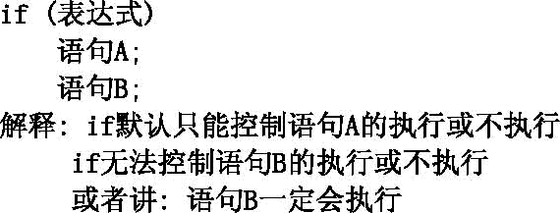

2.



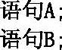





]. if..else... % %

4. if.. else if ..else ..% %

if ()

A;

else if (2)

Bi

else if (B) C.

else



###### 6. if*{B1 — #####

**7. if L%A*(»d##l**

if (O )2);

if (z›z)



if (WfiK1)

A;

else

B

**if (B%K );**

A ;

else

B

###### if(AMAi)

A

else if (%% 2)

B

else if ( %AO) C.

else





if ( %#1)

A.

else if ( é 2)

B

elseif(WfiKO )

#.

% %i%%1%%#' lll%%l%#





e1





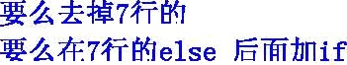







else







sri tch

for

else



for 1; 2; ]) **//1**

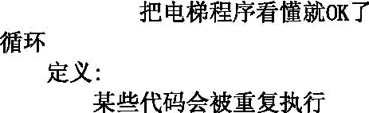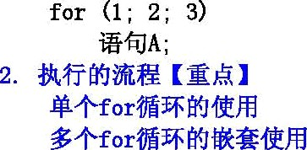

for (4 **5; 6) //2**

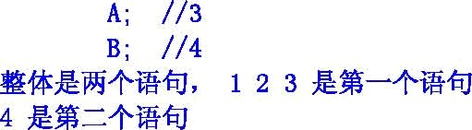

for ; 2; B)



for (4 5; 6)

A;

B;



for (1 ¡ 2 ¡ 3)

#### A;

B;

###### for (4; 5; 6)

C.





1 + 2 + 3 + + 100

1 + 1/2 + 1/3 + . . . . + 1/100

whi le



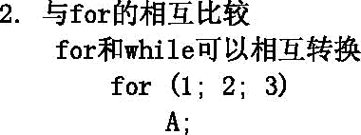



#### A;









do. . . whi le

do



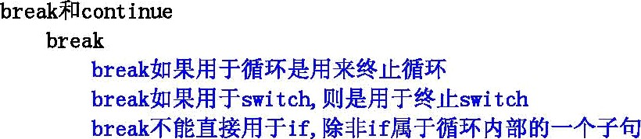

for (i=O; i(] ++i )

if (3 )2)

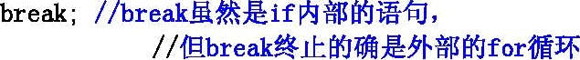

**Drintf( 'n’); //ÆÄ1ÃĘi**



for (iK; i(]; ++i)

**for (j=1; j(4¡ ++j)**



**Drintf( ’ ś{Ü Ą !\n’);**



**int x=1 r=0 a=O b# ; œitchx) // k- svitch**



case 0:

**break //ĄMØ # s*itch**

case 1:

## b**;

### break;

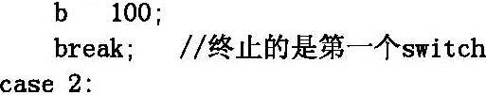

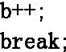

cont inue

**printf( ’%d %d\n’,e, b); //26İÏ**

for (1; 2; ])

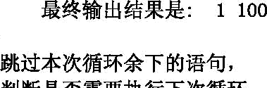

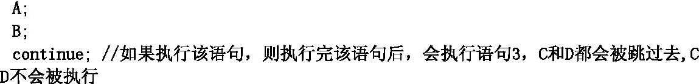

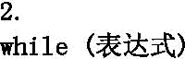

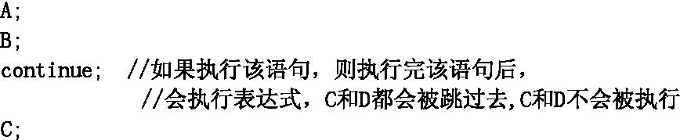

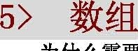

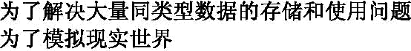



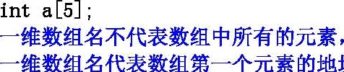

int a [5j = İ1, 2, 3, 4, 5} ¡

int a [5j = {1, 2, 3} ¡

int a [5j ¡

int a [5j = {0) ¡

**int a[5];**

afS7 = {1,2,s,4,S}: **//fi%**



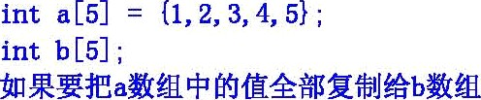

b = a ¡ // error

for (iK; i(5; ++i)





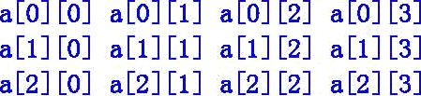



int «[3j[4j = (1,2,3,4,5,6,7,8,9,10,11,12};

int a[3j[4j = {

(1 2, 3 4),

(5, 6, 7, 8},

(9, 10, 11, 12}

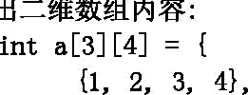

(5 6 7 8 ,

(9, 10, 11, 12}

int i, j ¡



for j=O; jK4 ++j)

printf(’#d ’, a[ j[J j);

printf G\n’);

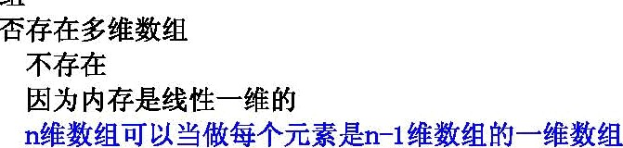



**9,*Ü#”ÑÑ#%Ü \*** 4*'1•ÑÑ

### int a[]j[4j[5L





   

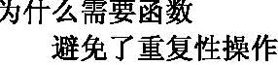

 





2 retxn Ã/; (fjĄ :

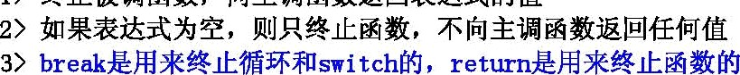

void f()



**int f Ü**





**int f Ü**

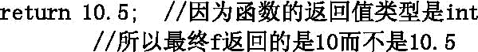











double sqrt (double x) ¡

int abs pint xJ

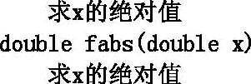

 

void f(:nt :)

int j = 20 ¡

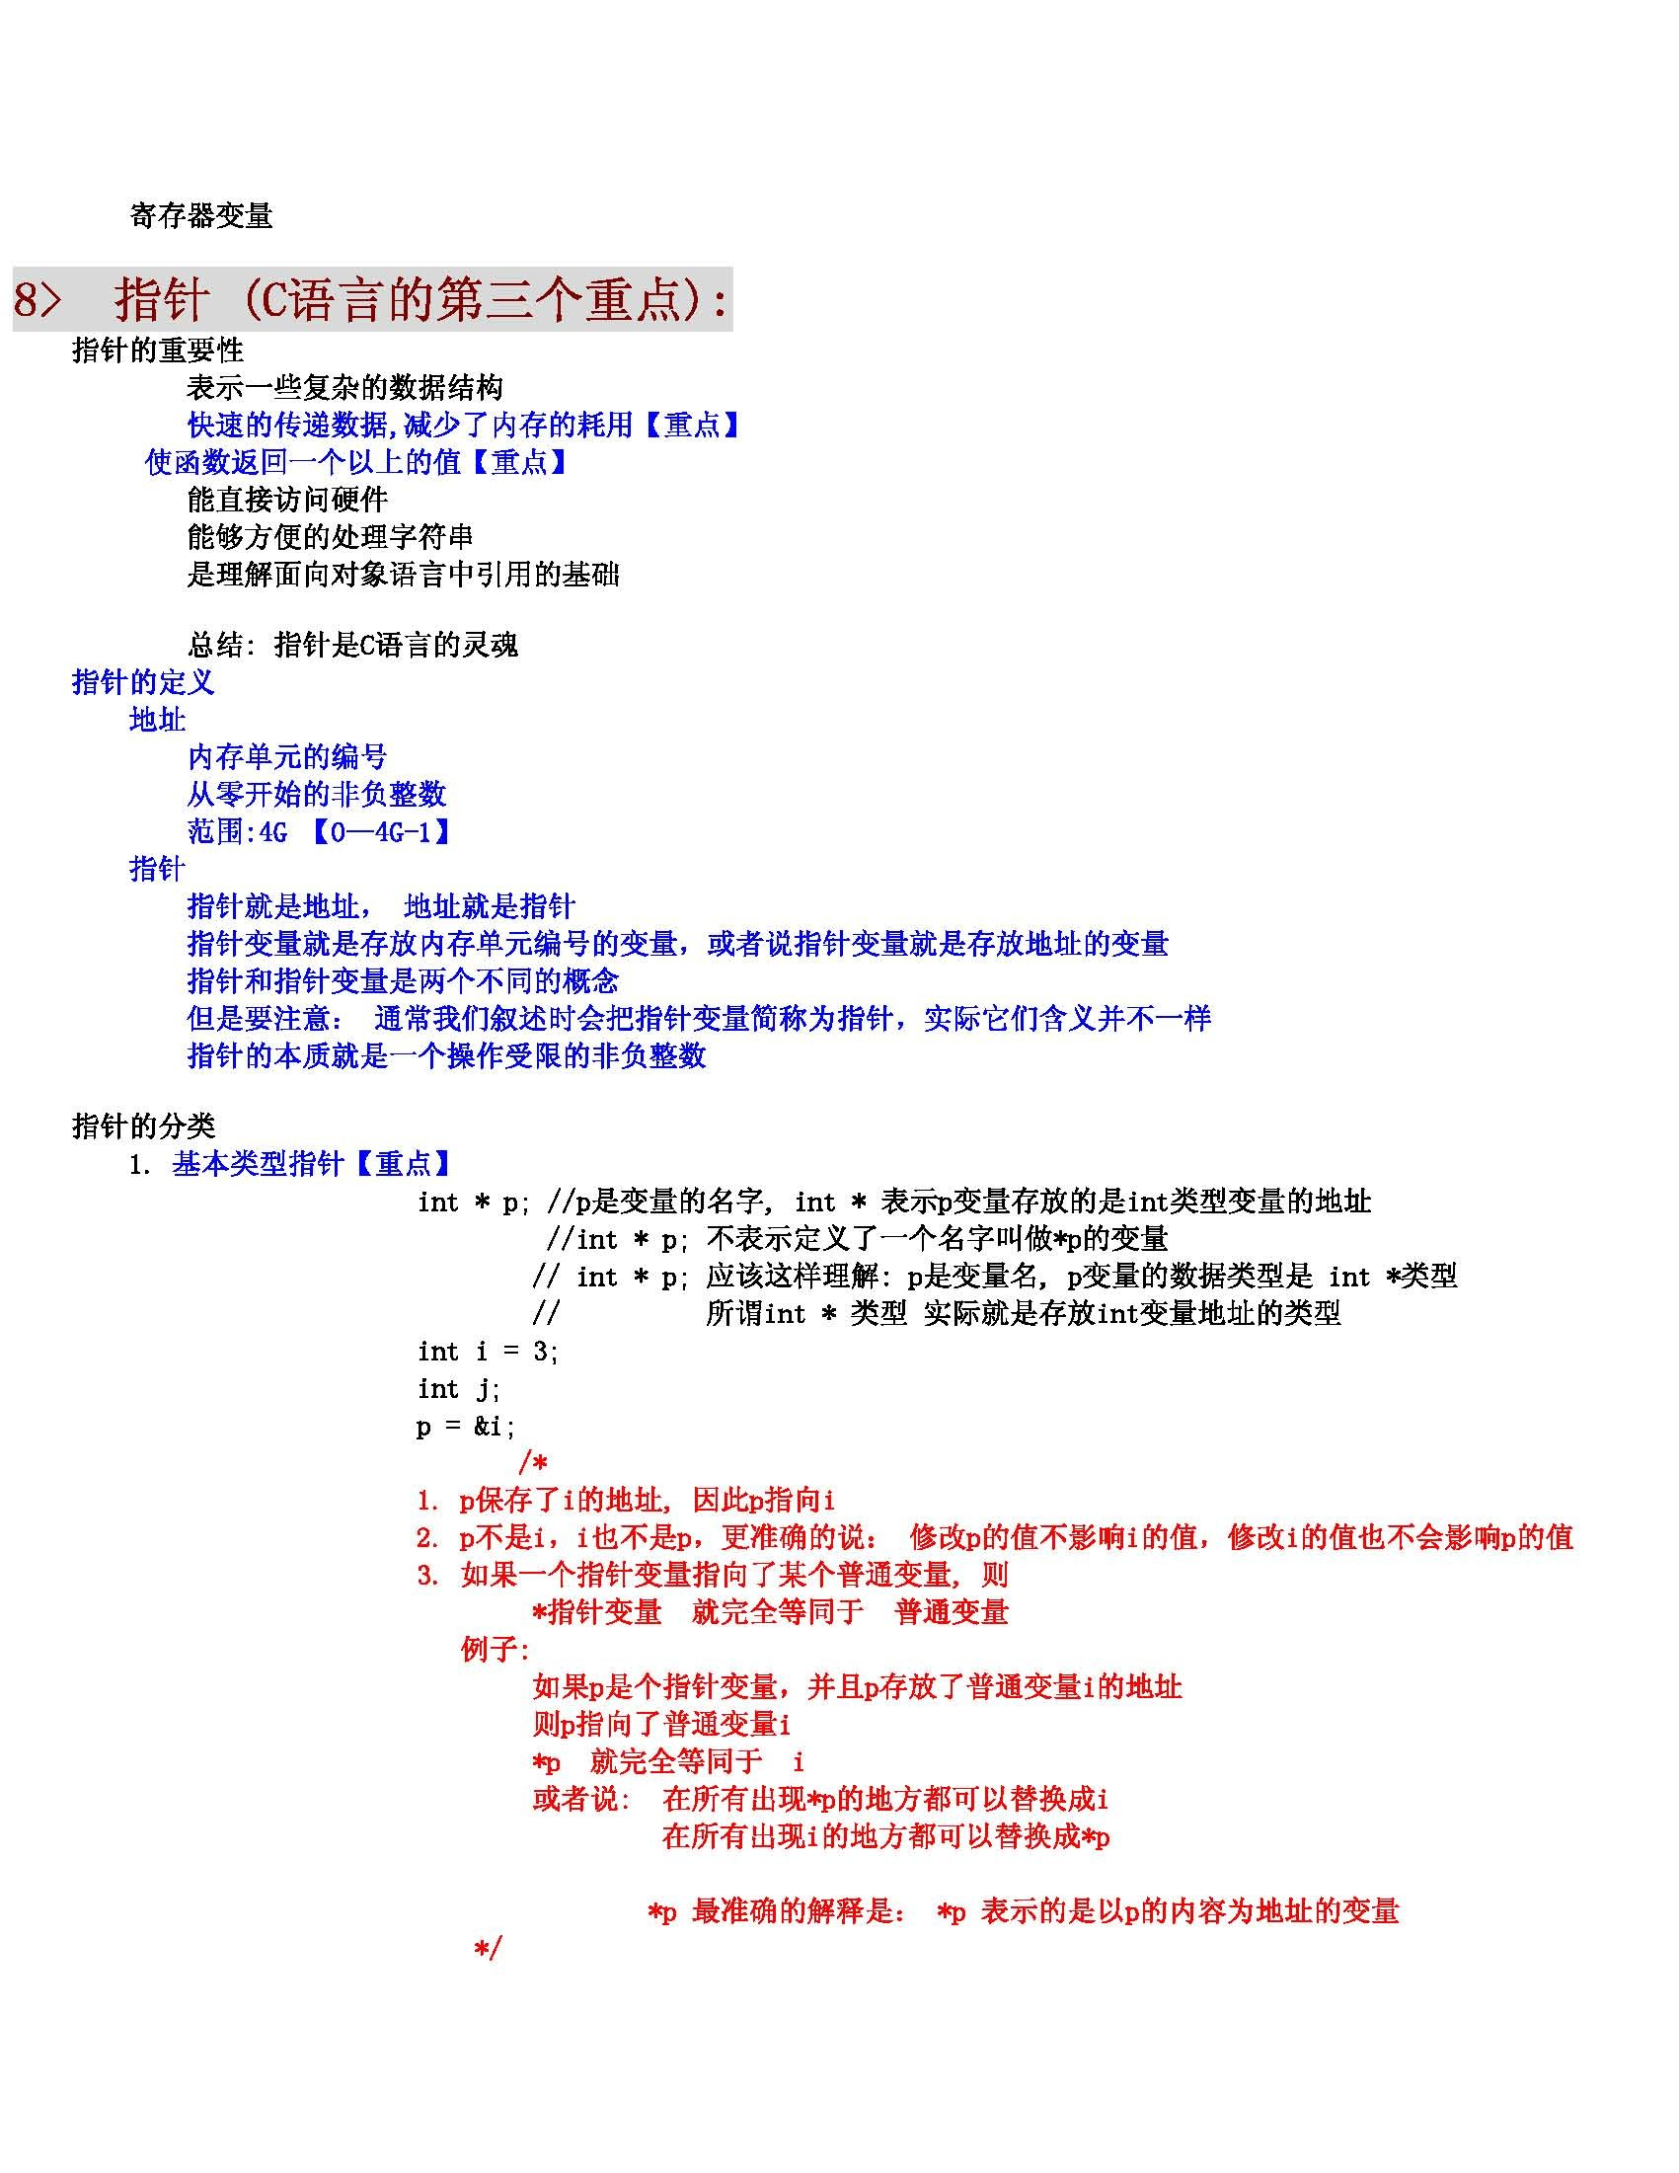

printf(’i = $d, j = Zd \n’, i, j) ;

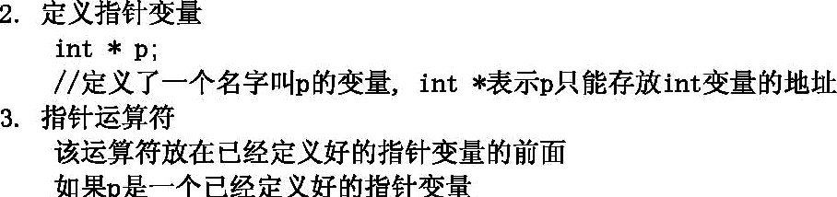





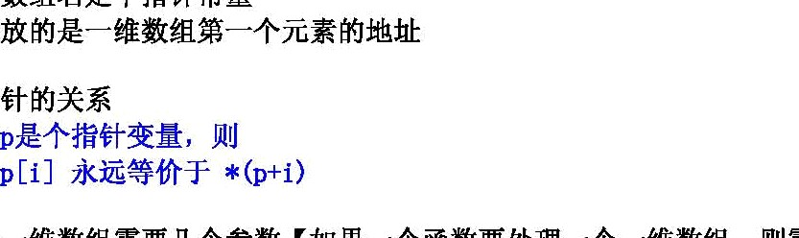

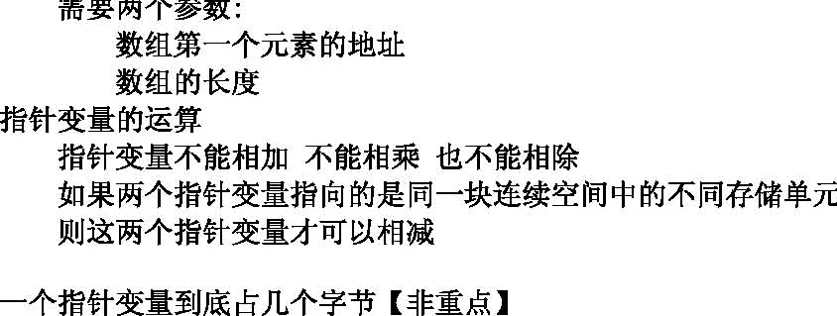

siseof(ÆÆÆÆ)

**]#: sizeof(int)** = **4 sizeof(char)** = 1

**sizeof(òouble)** = 8

sizeof(ÆÆÆ)

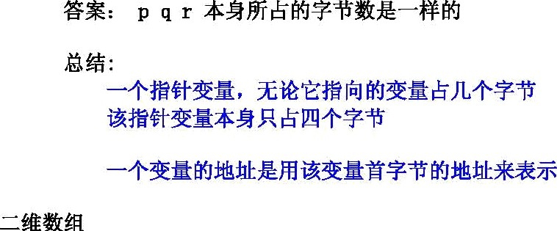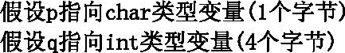



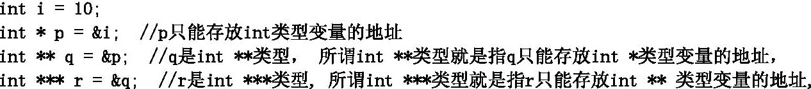

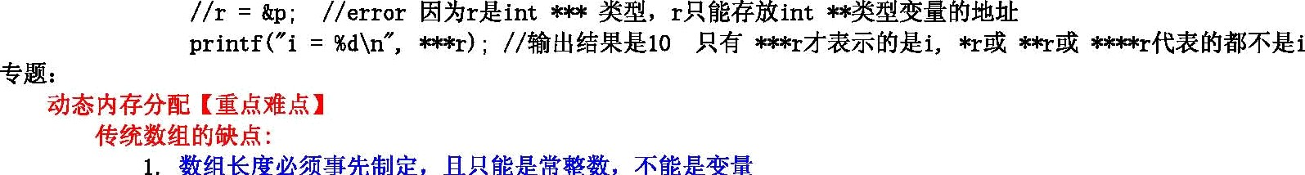

int a [5j ¡ //0K

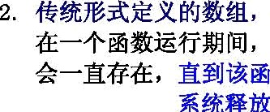

**int len** = ï

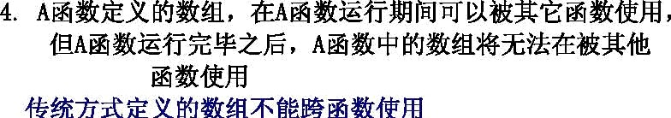

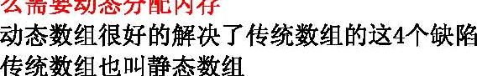

**8%%fiN%-+ınt ¥-fiB (Yì fi#¥** ! )

**int Ą** = **int *)malloc(nt let;**

1. **& &*ÆTMÆ8P .** — ÆH& **%**Æ(ü,**

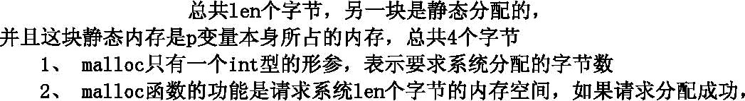











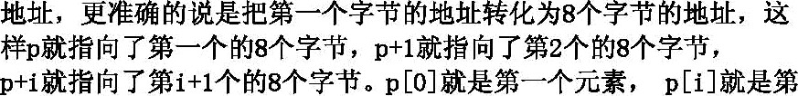



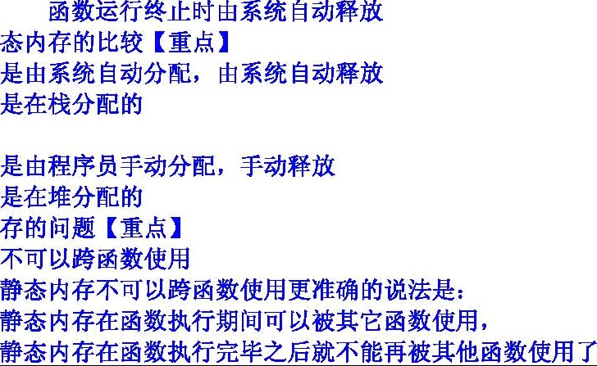

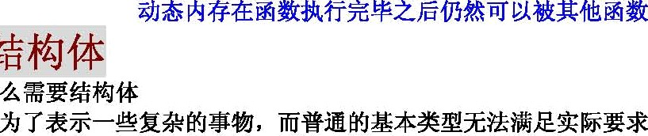



struct Student

int age ¡ float score ¡ char sex ¡

##### struct StuJent2

int age ¡ float score ; char sez ;

} st2 ¡



**int age; float wore;** char sex ¡

} st3 ¡

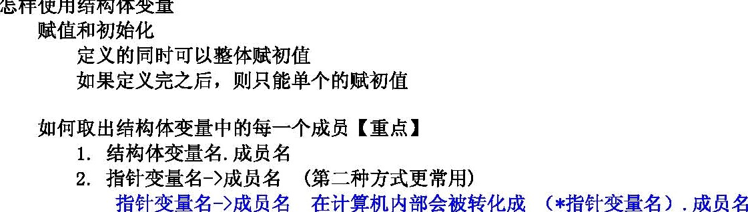

##### struct Student

**int uge; flott score** char sex ;

###### int main(void)

stzuct Student st (80, 66. 6, ’ P’ } ; ***//@*** / Q $j[F]‹ @@@



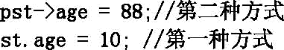

return 0 ¡



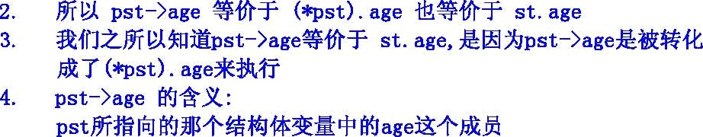

**struct Student**

int age ¡

char sex ;

char naaie [100d ;

**struct Student st1 st2;**

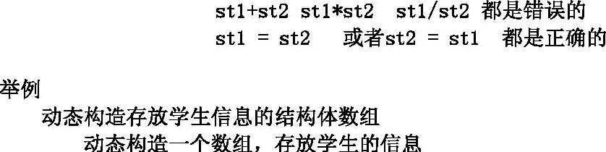



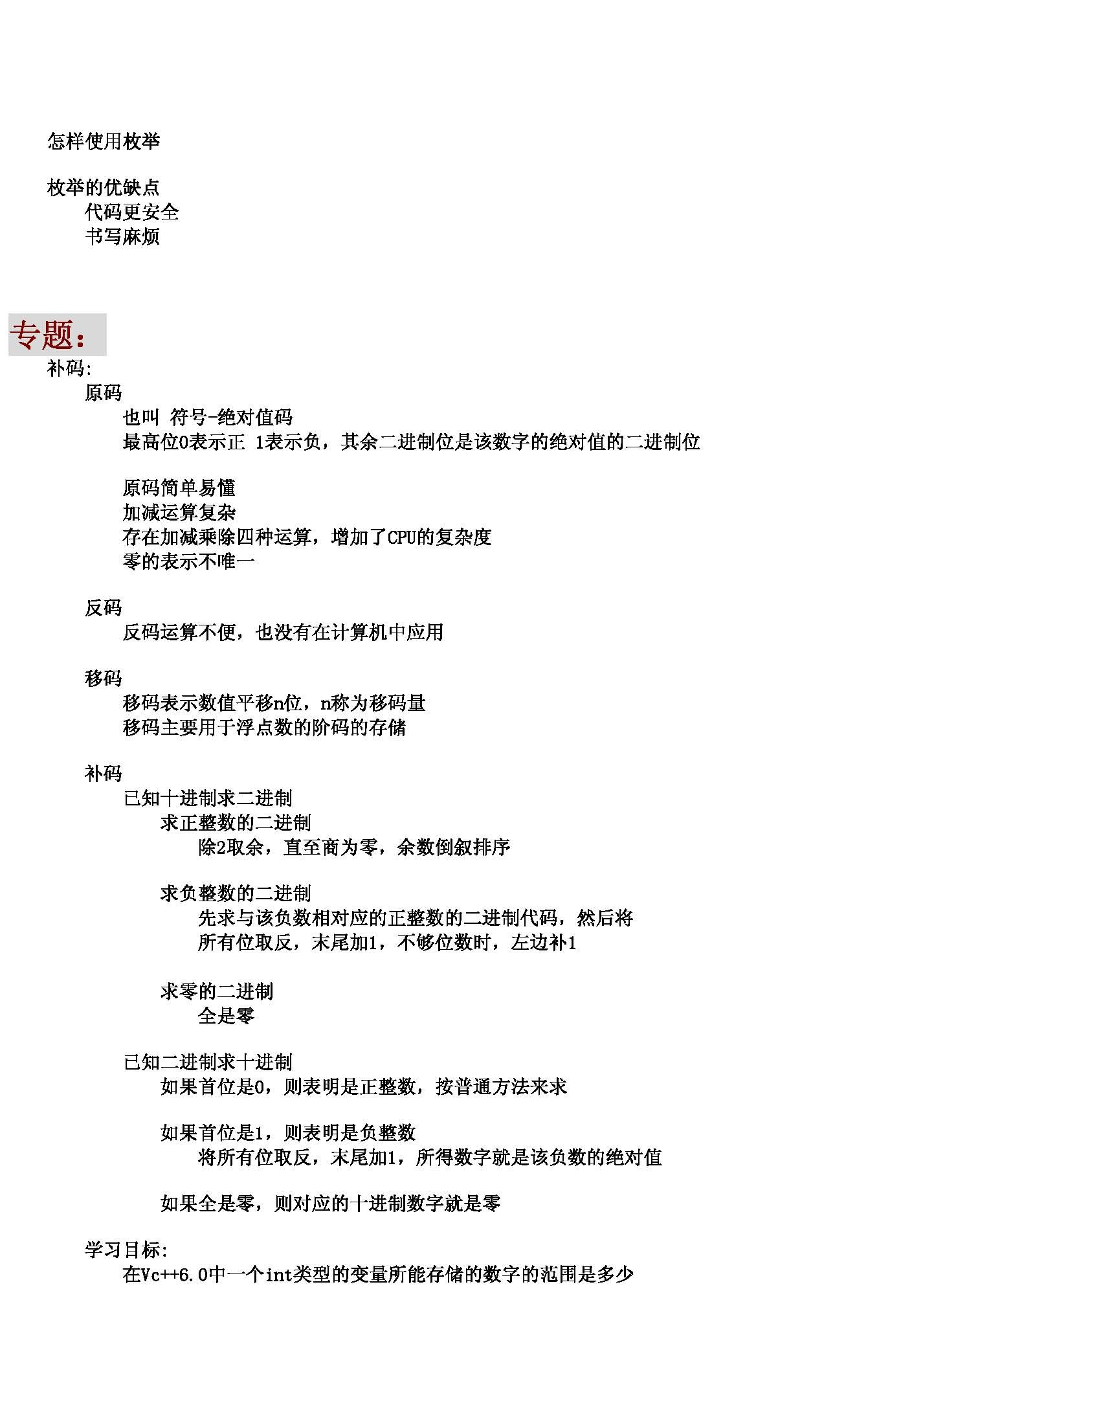

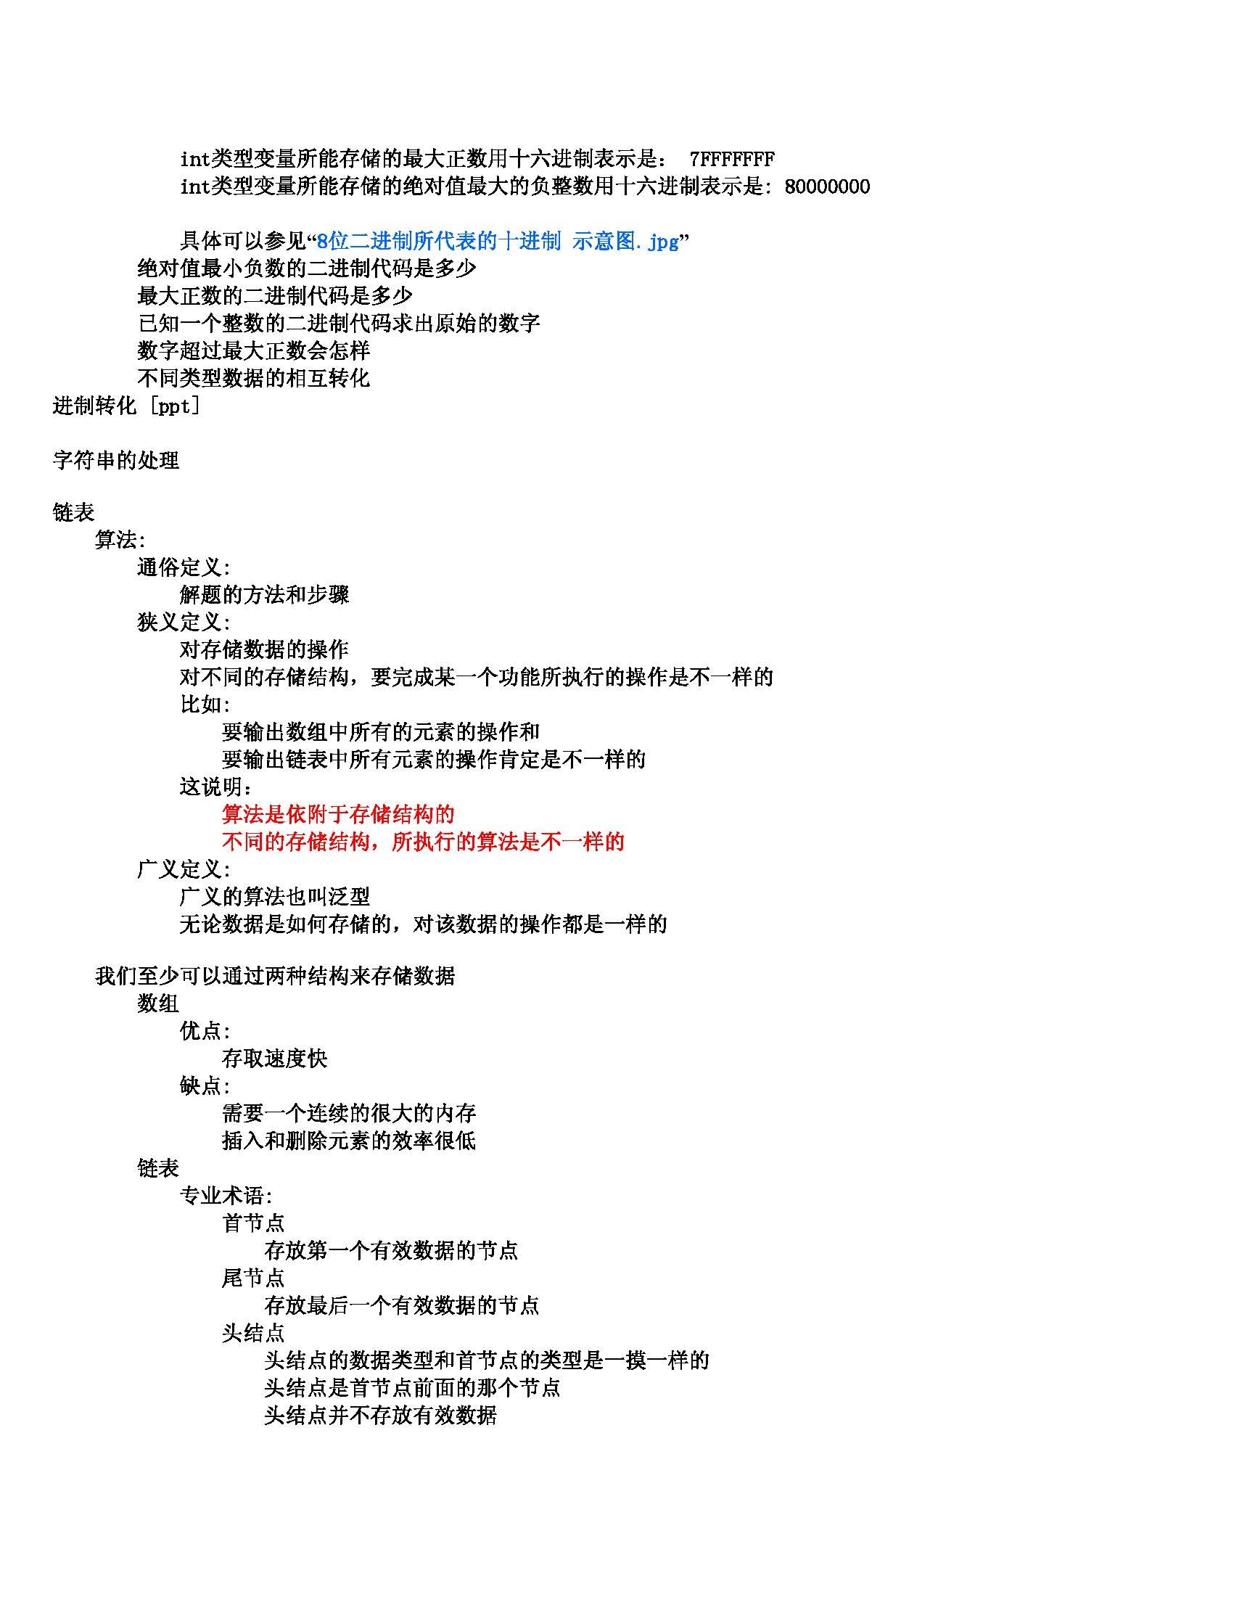

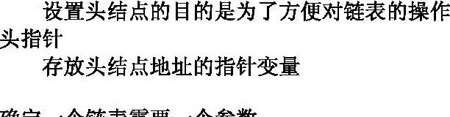



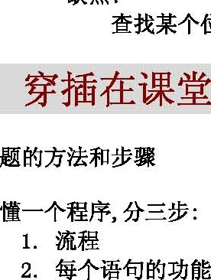

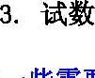

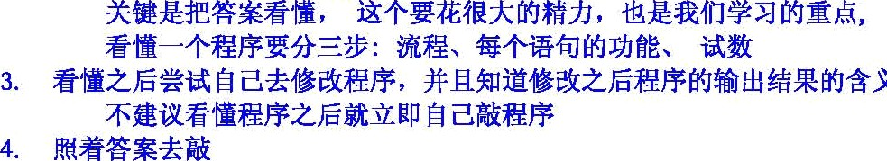









**(float)Œ) Æ%** Æ s. o0oooo

**float double Ą*Ñ%fETŒÜ ØØØfiØĘ#ĘØ%#ØńĘØ1**

floet i = 999; printf( ’%f\nŻ il;

# Yc++6. 0 ĄĄÃ# : 99.900002



#### if ( -O.0OO0Oı } ‹=O.OOOO0ı)

else

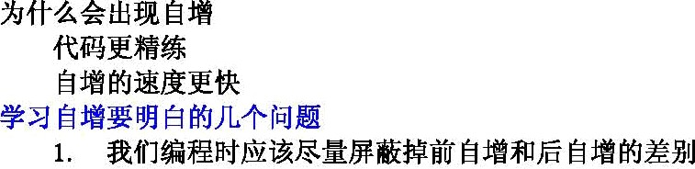









if (Æ

B;

else



(A, B, C, D)

**#ÊË:**

**#2' łJ%İİ**

Å —

1 0 0

0 1 0

0 0 0



110 1

OI 1 1

OIO O

|  |  |
| --- | --- |
| 1’O | 1 |
| 0’1 | 1 |
| 1’1 | 0 |
| 0’0 | 0 |



1. i = i*8 ;
2. i = i śś3 ¡







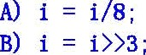















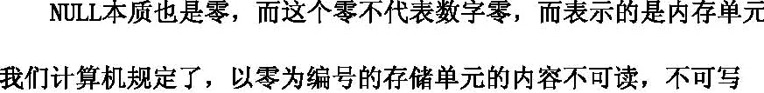

The end 2009@12,Q 1 b]